FINAL ASSESMENT

**Step 1: Home Page**

In this step, I created the **main landing page** for the website. I designed a **navigation bar** with links to different sections like "Home," "About Me," "Contact Me," and "Books." I also included a **search bar** for easy navigation. The page layout follows a structured format with a footer containing book links, contact details, and social media handles.

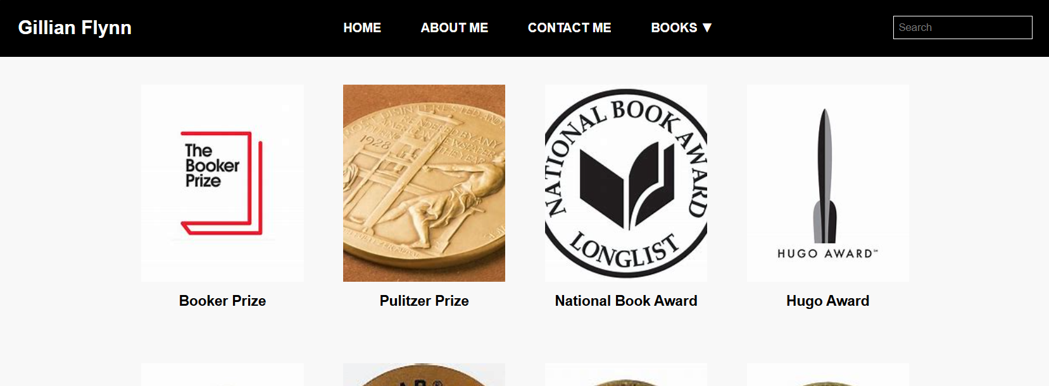

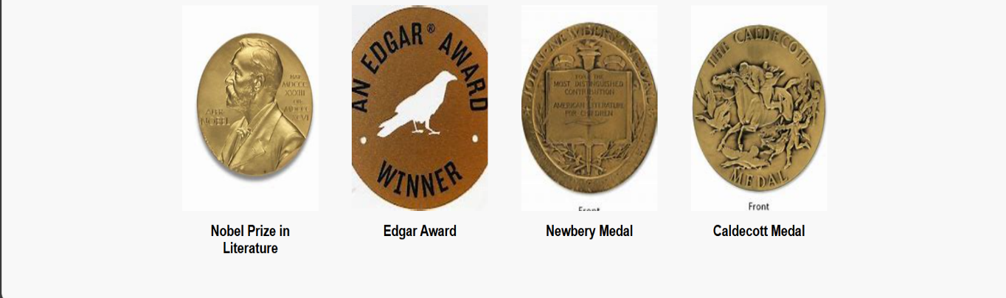

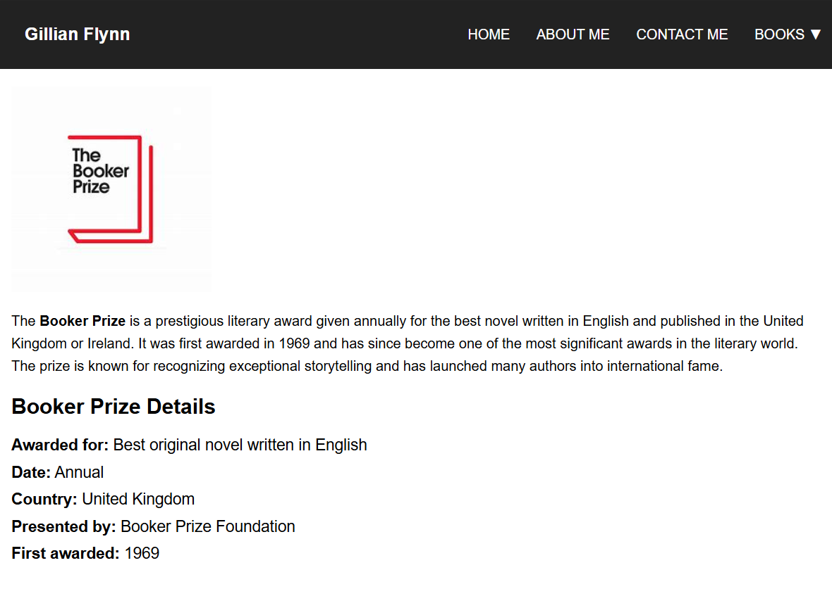

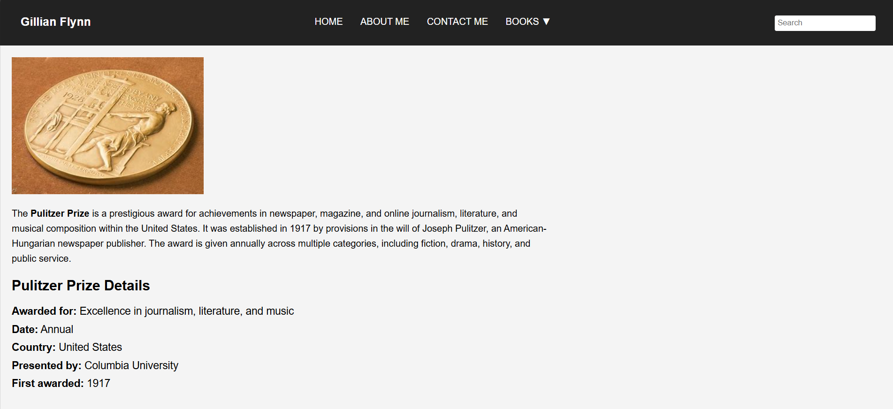

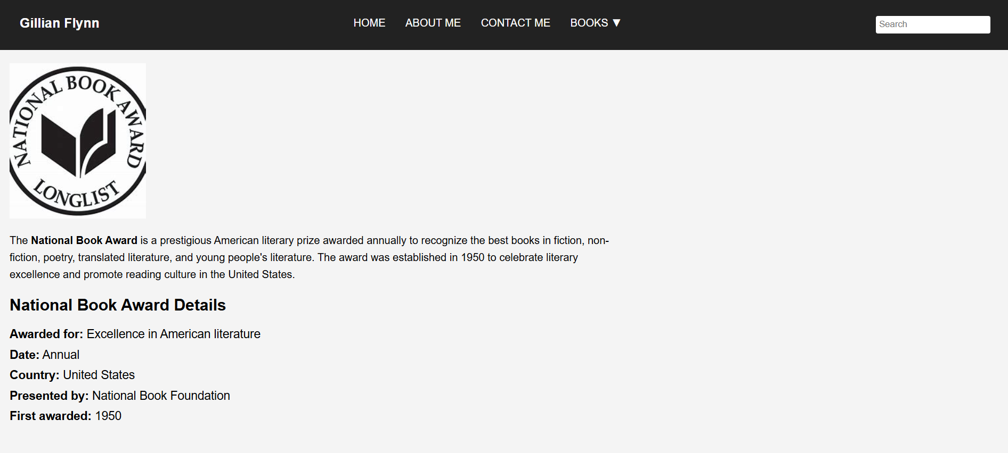

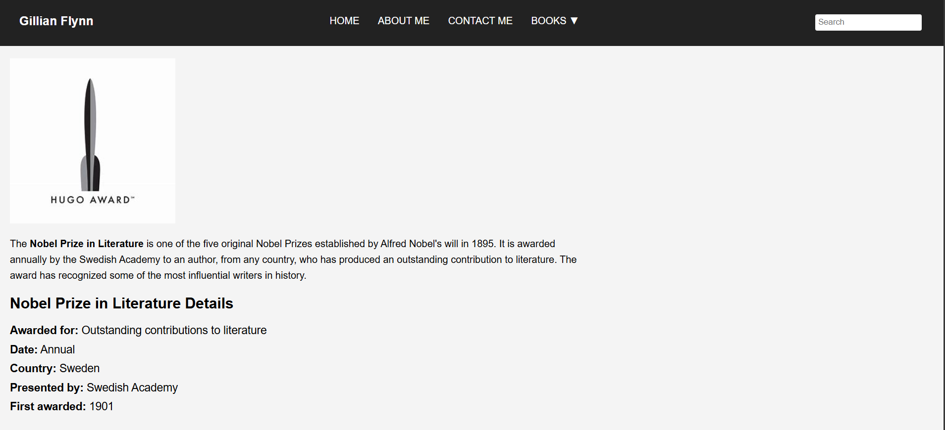

**Step 2: About Me Page**

In this step, I built the **About Me** page, which provides details about the author **Gillian Flynn**. It includes a **brief biography**, an **image**, and information about her career and writing style. This page helps visitors learn more about the author’s background and literary achievements.

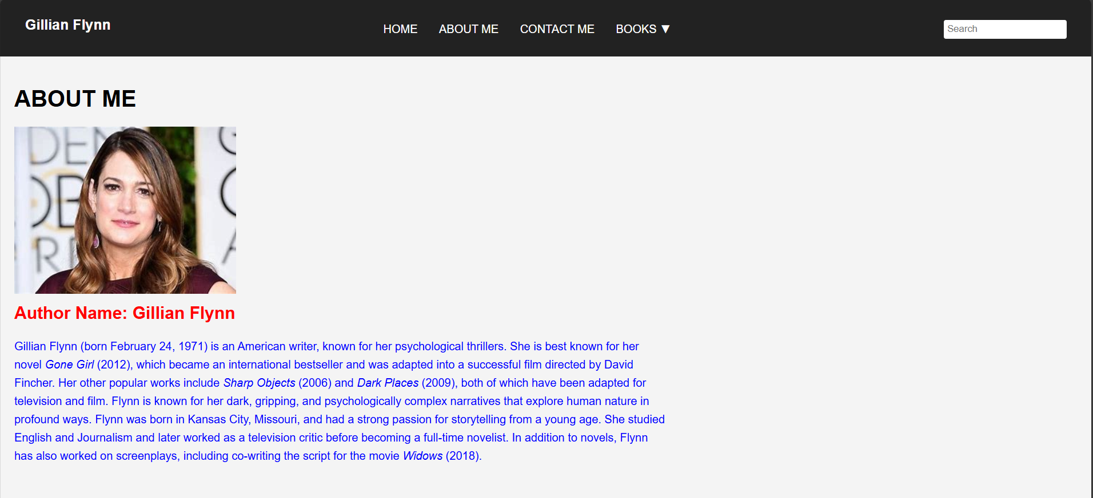

**Step 3: Contact Me Page**

This step focuses on adding a **Contact Me** section where users can find the author’s **email, phone number, and social media links**. I also included a **Contact Page button** to encourage interaction. The footer is consistent with other pages, ensuring a seamless browsing experience.

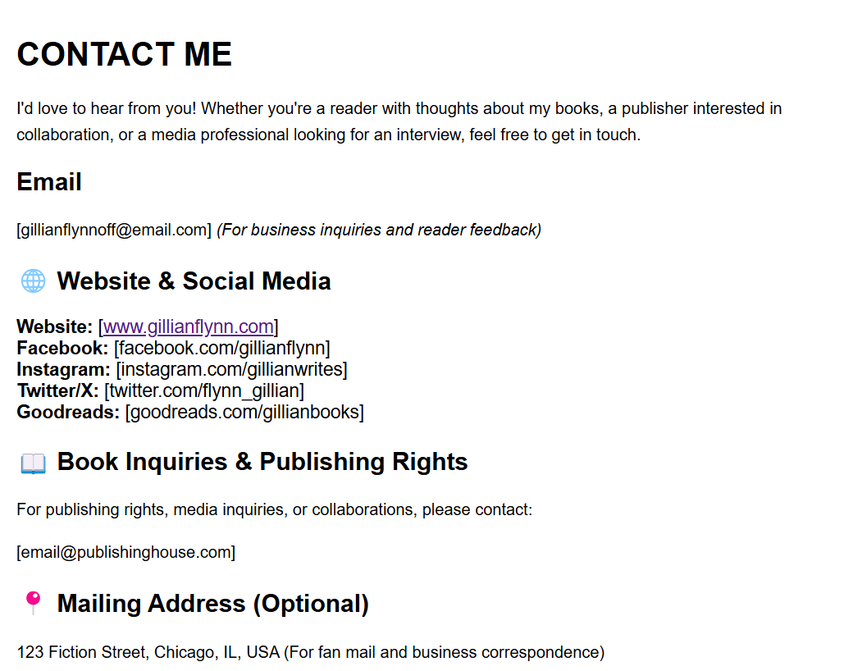

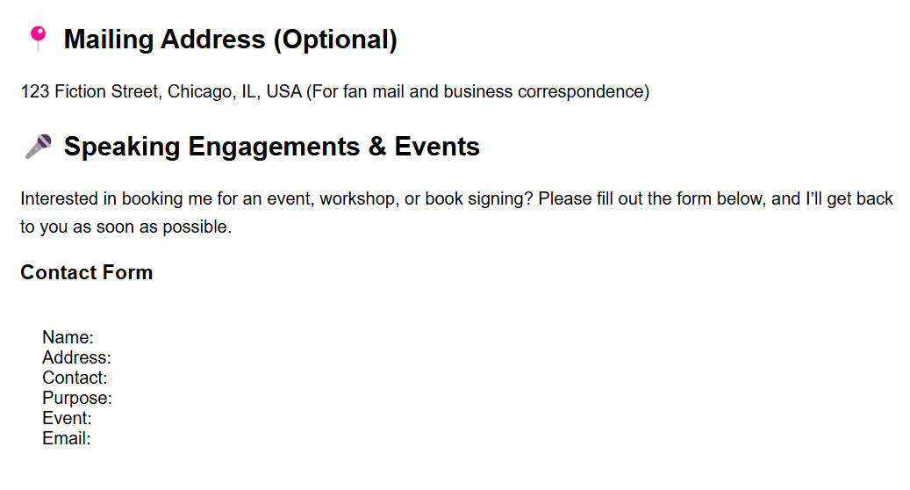



**Step 4: Books by Author Page**

In this step, I created a dedicated **Books Page** featuring **six books** by Gillian Flynn. Each book has a **title, cover image, and description**. The layout is structured to make it easy for visitors to explore her works. This page is designed to be visually appealing while maintaining a professional look.

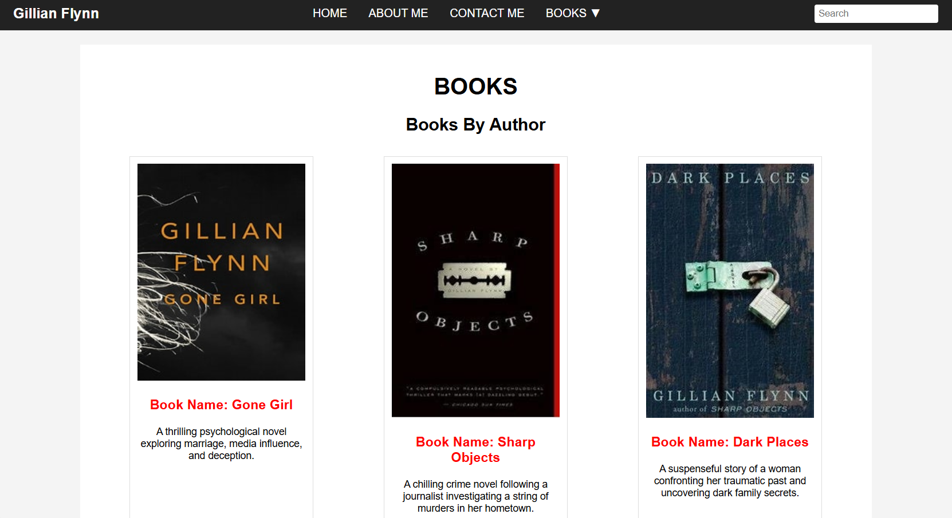

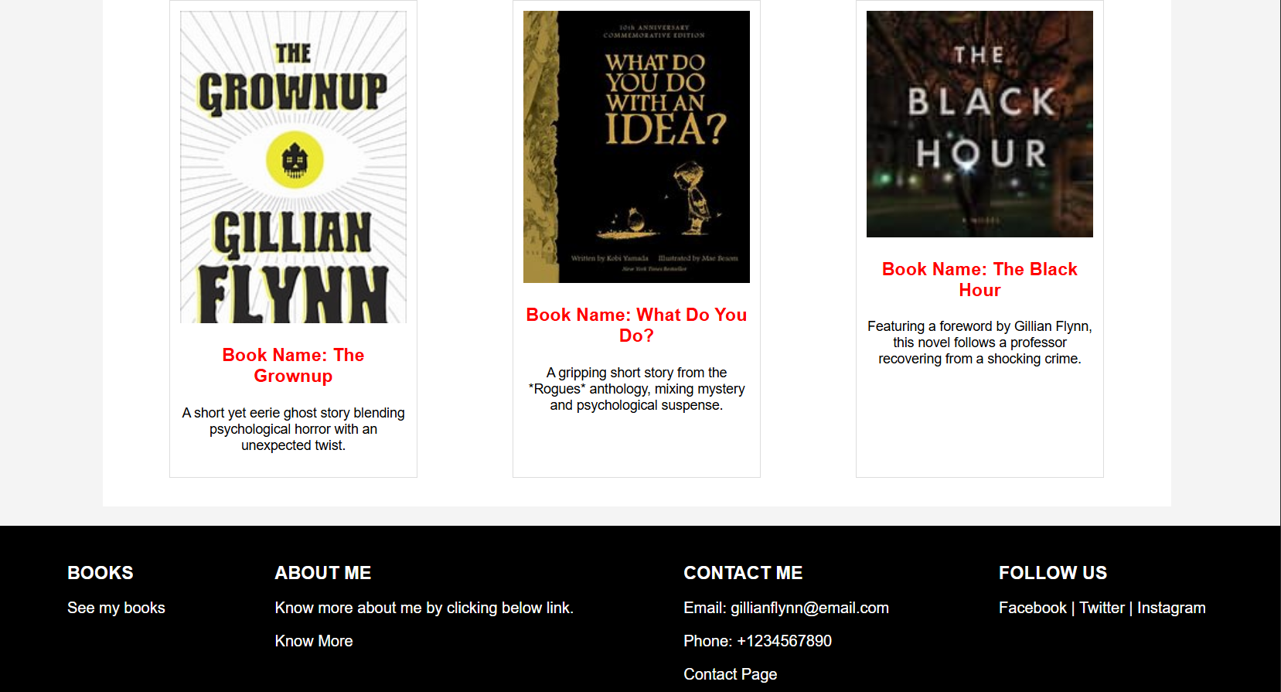

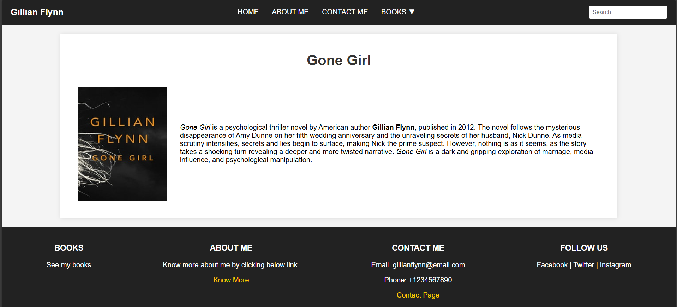

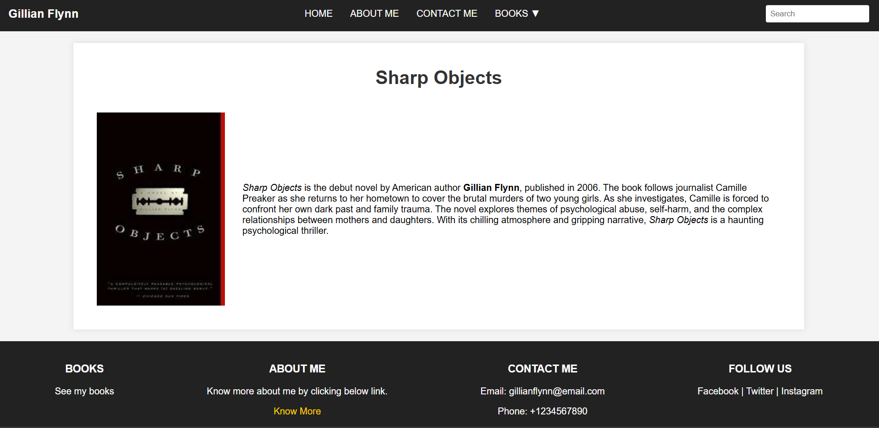

**CODING PART:**

